Name:  Teacher : | ____________________________________  ______________________ |  | Date:_________
 | Year 12 Essentials  /  Time  Full working out MUST be shown to get full marks for each question.
Total Time: | 30 minutes
Weighting: | 5%
Equipment: | Pen, pencil, ruler, scientific calculator.

Q1) Match the correct shape to its net: [ 5 marks]
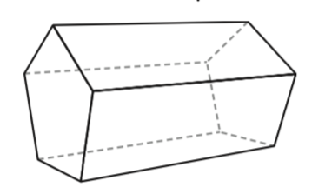  1 | 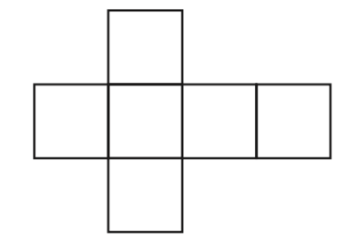  A
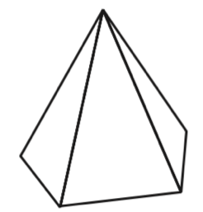  2 | 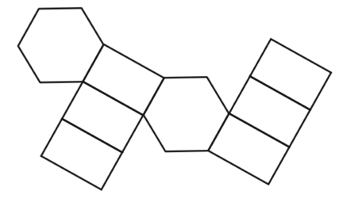  B
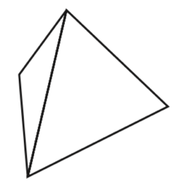  3 | 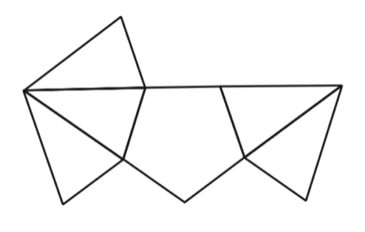  C
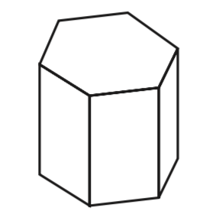  4 | 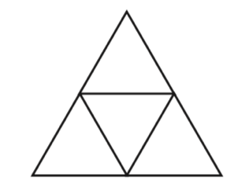  D
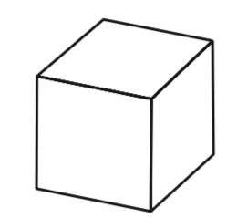  5 | 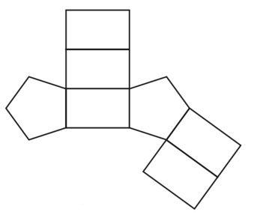  E

Q2) Define the following terms: [ 3 marks]

- A Vertex is a _____________________________

- A Face is a _______________________________

- An Edge is a ____________________________________

Q3) Complete the following table [4 Marks]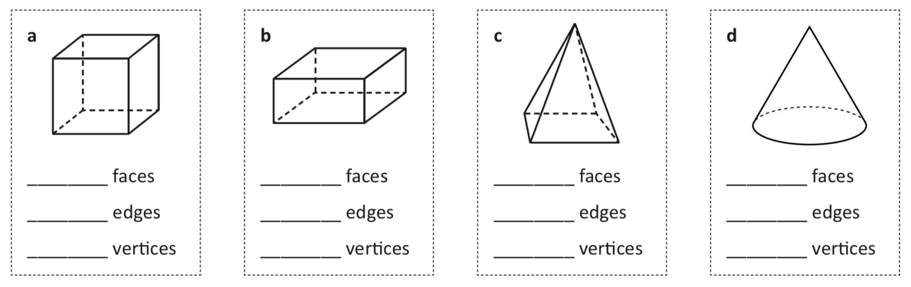
Q4) Eulers formula states that for all 3-D shapes, when adding the faces to the Vertices, then subtracting the edges you will always receive an answer of 2. [3 Marks]
- Does this formula hold true for the shapes above?

- Is there a common 3-d shape above that this rule does not work for? Why?

Q5) Using the following shape, Draw the front, right and top views of this shape:
Isometric drawing | Front view | Right view | Top view
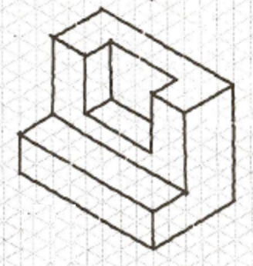

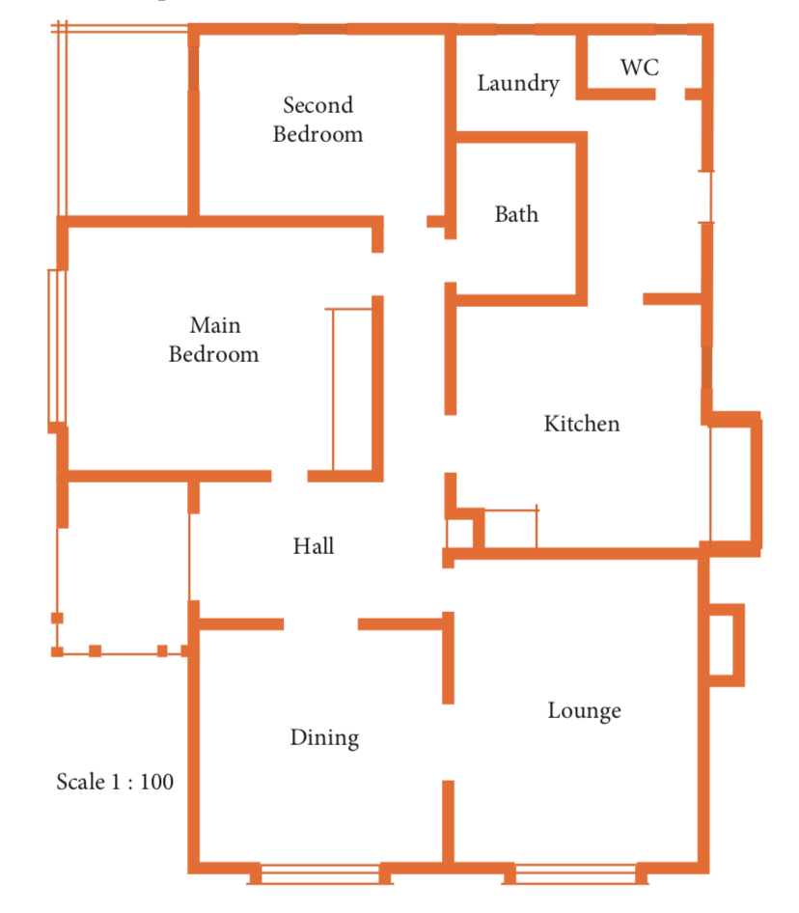
Q6) The houseplan below is draw to a scale of 1:100. Use this information to answer the following. [14 mark]

- The length of the dining room is 4.5cm by 4.5cm. How long would this be in real life?

- The house will have tiles in the Laundry, Toilet, Kitchen and Bathroom. This is a rectangle that is 9.5cm by 4.5cm on the plan. How big is this area in the real world?

- If 1 pack of tiles cost $80 per square meter, how much would it cost to tile this area?

- The loungroom has an area of 24.75m². What is this in square cm?

- The main bedroom is 5.5cm by 4.5cm, and the second bedroom is 3.5cm by 4.5.cm. They choose to use carpet tiles 800mm x 800mm. They come in a pack of 15. How many packs would they need to purchase to cover both rooms?

END OF ASSESSMENT

